CYBERSECURITY ASSESSMENT REPORT
Prepared for: Cyber1Defense Lab
Prepared by: Bendi Caleb YONLI
Tel: +226 71782892 / 0557230269
Date: 24 May 2026

1. Executive Summary
This report presents the findings of a network traffic assessment conducted on the internal subnet 192.168.100.0/24. The objective was to identify anomalous behavior, potential security risks, and misconfigurations through packet-level analysis.
The assessment revealed several notable issues, including ARP storming activity, excessive IoT-based service discovery traffic, and outbound encrypted communications to external services. These findings indicate a network environment with increased exposure to reconnaissance, potential lateral movement, and information leakage.
Overall, the network security posture is assessed as Moderate to High Risk, primarily due to suspicious ARP activity and the presence of unmanaged or overly communicative IoT devices.
Immediate remediation actions are recommended to strengthen network segmentation, monitoring, and protocol control.

2. Scope and Methodology
2.1 Scope
- Internal Network: 192.168.100.0/24
- Focus: Internal traffic behavior and protocol analysis
2.2 Tools Used
- Wireshark – Packet capture and deep traffic inspection
- Protocol analysis of:
  - ARP (Address Resolution Protocol)
  - SSDP (Simple Service Discovery Protocol)
  - mDNS (Multicast DNS)
  - DNS (Domain Name System)
  - TLS/QUIC (Encrypted traffic)
2.3 Methodology
The assessment followed a passive traffic analysis approach:
- Capturing live network traffic
- Filtering protocol-specific communications
- Identifying abnormal patterns and repeated behaviors
Correlating traffic sources with potential risks

3. Findings
3.1 Finding 1: ARP Storming Activity
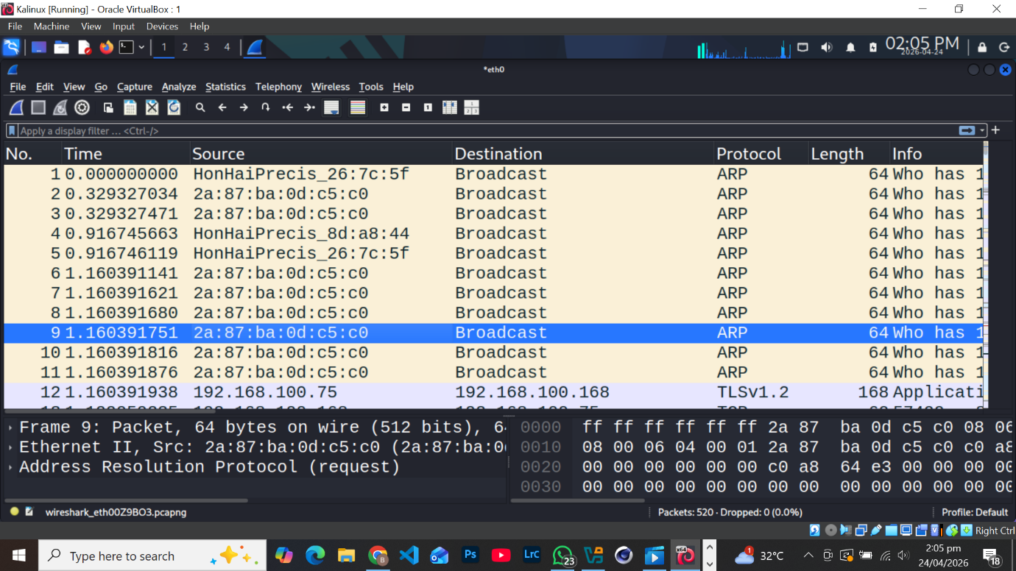

Risk Level: High
Description:
A high volume of ARP broadcast traffic was detected originating from a single MAC address (2a:87:ba:0d:c5:c0), indicating abnormal behavior.
Evidence:
- Repeated ARP requests observed in rapid succession
- Broadcast queries targeting multiple IP addresses
- Traffic pattern consistent with scanning or misconfiguration
Affected Host:
- 192.168.100.102
Impact:
- Potential reconnaissance or ARP poisoning attempt
- Network congestion and degraded performance
- Increased risk of man-in-the-middle (MITM) attacks

3.2 Finding 2: IoT SSDP Traffic Flood
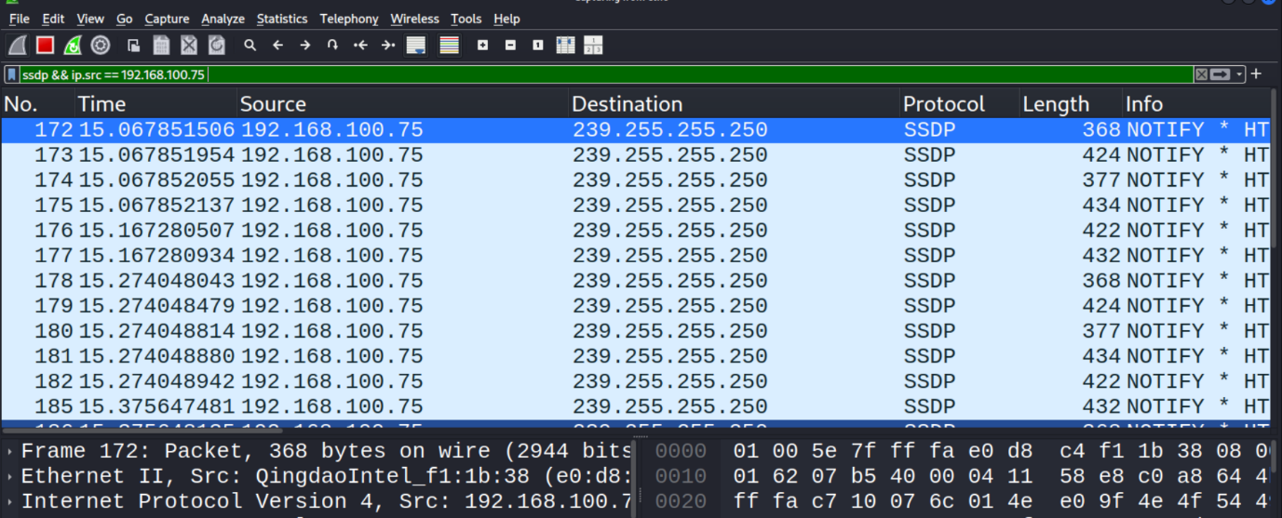

Risk Level: Medium
Description:
An IoT device is generating excessive SSDP NOTIFY messages, indicating frequent service announcements.
Evidence:
- Source IP: 192.168.100.75
- Continuous SSDP multicast traffic observed
- High frequency of device discovery broadcasts
Impact:
- Increased attack surface due to device visibility
- Potential exploitation of UPnP vulnerabilities
- Network noise affecting performance

3.3 Finding 3: External Encrypted Communications (TLS/QUIC)
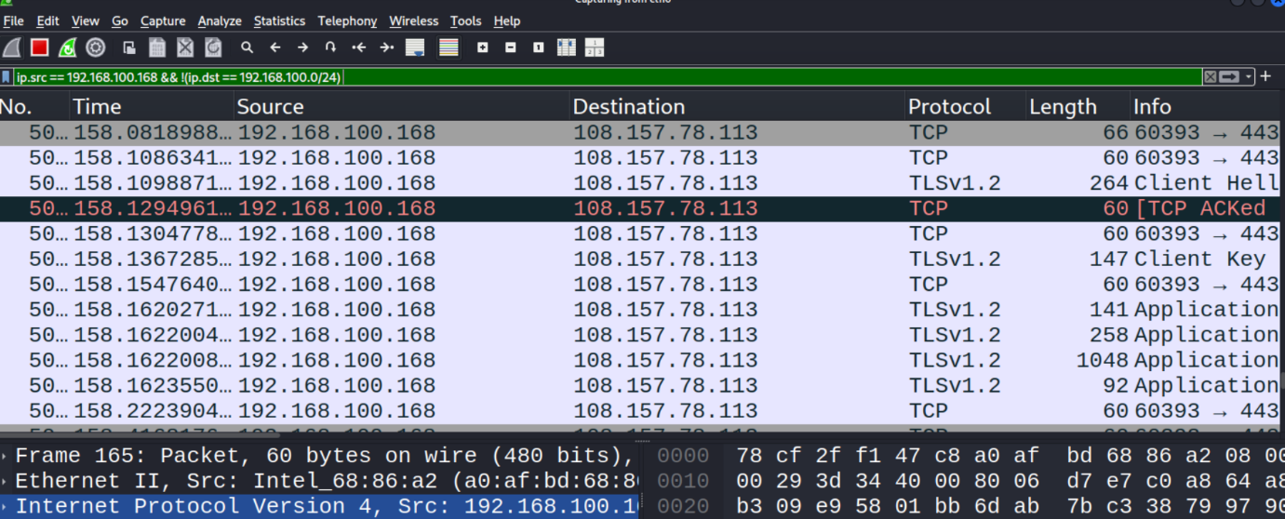

Risk Level: Medium
Description:
A host is establishing multiple encrypted sessions with external services, including telemetry and CDN providers.
Evidence:
- Source IP: 192.168.100.168
- Connections to Microsoft telemetry services and Cloudflare endpoints
- Use of TLS and QUIC protocols
Impact:
- Limited visibility into encrypted traffic content
- Possible data exfiltration risk if endpoints are compromised
- Normal behavior, but requires monitoring

3.4 Finding 4: Multicast DNS (mDNS) Exposure

Risk Level: Low
Description:
Devices are broadcasting service information over mDNS, exposing internal service details.
Evidence:
- Source IP: 192.168.100.85
- Broadcast of TXT records and service identifiers
Impact:
- Information leakage (device names, services)
- Useful for attackers during reconnaissance
- Low direct exploitation risk

3.5 Finding 5: IoT Device Announcements
Risk Level: Medium
Description:
IoT devices (e.g., smart home devices) are actively announcing IP ownership and availability.
Evidence:
- Observed device announcements consistent with smart devices (e.g., Ring-like behavior)
- Frequent broadcast messages
Impact:
- Increased network exposure
- Potential targeting of vulnerable IoT devices
- Weak security controls typical in IoT environments

4. Affected Assets Summary
Host IP | Device Type | Issue Identified | Risk Level
192.168.100.102 | Unknown Host | ARP Storming | High
192.168.100.75 | IoT Device | SSDP Flooding | Medium
192.168.100.168 | Workstation | External TLS/QUIC Traffic | Medium
192.168.100.85 | Network Device | mDNS Exposure | Low
Multiple Devices | IoT Devices | Service Announcements | Medium

5. Risk Analysis
- High Risk:
ARP storming represents a critical issue that may indicate active reconnaissance or preparation for network-based attacks such as ARP spoofing.
- Medium Risk:
IoT-related traffic and encrypted communications increase the attack surface and reduce visibility, making threat detection more difficult.
- Low Risk:
Service discovery protocols expose information but have limited direct exploitability without additional vulnerabilities.

6. Recommendations
To improve the network security posture, the following actions are recommended:
Network Security Controls
- Enable Dynamic ARP Inspection (DAI) on network switches
- Configure port security to limit MAC address abuse
Network Segmentation
- Isolate IoT devices into a dedicated VLAN
- Restrict communication between IoT and critical systems
Traffic Monitoring & Filtering
- Implement DNS filtering and monitor outbound connections
- Deploy IDS/IPS systems to detect abnormal traffic patterns
Protocol Hardening
- Disable unnecessary services such as:
  - SSDP / UPnP
  - mDNS (where not required)
Device Management
- Identify and investigate host 192.168.100.102
- Ensure all devices are updated with latest security patches

7. Conclusion
The network assessment identified multiple areas of concern, particularly related to ARP anomalies and IoT device behavior. While no confirmed exploitation was observed, the detected patterns indicate potential security weaknesses that could be leveraged by an attacker.
Addressing these issues through segmentation, monitoring, and protocol control will significantly reduce risk and improve overall network resilience.
Proactive implementation of the recommended controls is essential to prevent future security incidents.

8. Appendix
8.1 Supporting Evidence
- Packet capture excerpts from Wireshark
- Filtered protocol analysis (ARP, SSDP, DNS, TLS)
8.2 Visual Aids (Recommended for Final PDF)
- Network traffic heatmap
- Protocol distribution pie chart
- Host risk classification table
8.3 Glossary
- ARP: Address Resolution Protocol
- SSDP: Simple Service Discovery Protocol
- mDNS: Multicast DNS
- TLS: Transport Layer Security
- QUIC: Quick UDP Internet Connections
- IoT: Internet of Things

